4 specifications require changes

Hi Udacity Learner,  
You’ve made a great effort in your work on the project! Sure you have learned a lot and we encourage you to keep up with this hard work. Your submission is almost there in terms of meeting specifications, but there are a few small changes that are to be made before you pass the project. I have explained in detail the changes that are to be made so please go through the review.  
keep learning and be safe.

**Code Quality**

**All code is functional (i.e. no errors are thrown by the code). Warnings are okay, as long as they are not a result of poor coding practices.**

**Suggestion (To improve your skill)**

* If you want to learn more about python programming you can [follow this link](https://www.geeksforgeeks.org/python-programming-language/)

**The project uses functions and loops where possible to reduce repetitive code. Comments and docstrings are used as needed to document code functionality.**

**Suggestion (To improve your skill)**

* I am proving some link where you can learn more about [functions in python](https://www.geeksforgeeks.org/functions-in-python/)
* [You can go through this link](https://www.c-sharpcorner.com/blogs/why-comments-are-important-while-writing-a-code) to know the importance of comments in programming.

**Exploratory Data Analysis**

**The project appropriately uses univariate, bivariate, and multivariate plots to explore many relationships in the data set. Reasoning is used to justify the flow of the exploration.**

Univariate, bivariate, and multivariate plots are used.   
The reasoning is used to justify the flow of exploration. 

**Suggestion**

**You can go through the below-provided link to get some more insight into different types of plots.**

* [How to use Python Seaborn for Exploratory Data Analysis](https://www.justintodata.com/how-to-use-python-seaborn-for-exploratory-data-analysis/)
* [Univariate, Bivariate, and Multivariate](https://medium.com/@purnasaigudikandula/exploratory-data-analysis-beginner-univariate-bivariate-and-multivariate-habberman-dataset-2365264b751)

**Questions and observations are placed regularly throughout the report, after each plot or set of related plots.**

**Required**

* Questions were not used to explain the flow of the exploration report. writing a question before every visualization and then explaining it is a very good technique to express. It's just like telling a story.

[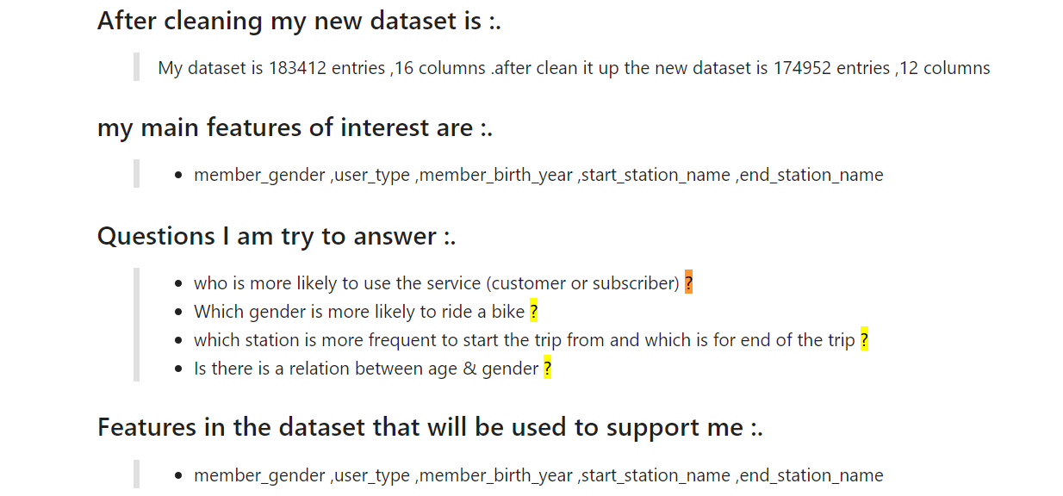](https://udacity-reviews-uploads.s3.us-west-2.amazonaws.com/_attachments/514237/1611997158/question.PNG)

* [You can go through this section in the course](https://classroom.udacity.com/nanodegrees/nd002/parts/9f7e8991-8bfb-4103-8307-3b6f93f0ecc7/modules/bc709f85-0ebb-45b8-907b-065adc25cbce/lessons/ffd7a28d-04d4-4c26-9e53-f2f3d85c4db7/concepts/3fd15c2e-b849-4bec-9bd2-6551140b3612) for a better understanding

**visualizations are not followed by enough observations. Observations are very important as it is very difficult to conclude any visualization by just looking at it. Each of your visualizations should be followed by proper observation.**

**Advantages of observation:-**

* Useful for Framing Hypothesis:
* Greater Accuracy:
* Independent of People’s Willingness to Report:

**Visualizations made in the project depict the data in an appropriate manner that allows plots to be readily interpreted. This includes choice of appropriate plot type, data encodings, transformations, and labels as needed.**

Suggestion

* If you want to know more about data visualization and best practices related to it [follow this Link](https://www.toptal.com/designers/data-visualization/data-visualization-best-practices)

**Explanatory Data Analysis**

**A section in the submitted materials includes a summary of main findings that reflects on the steps taken during the data exploration. The section also describes the key insights that are conveyed by the explanatory presentation.**

Dear student great work including the readme file in your submission and including some information related to your project but this is not the thing that we are looking for in the readme file.

**There should be two different sections included in your slideshow**

* A summary section that reflects on the steps taken during the data exploration.
* Key insights section that describes the key insights that are conveyed by the exploration presentation.

**I am also adding a screenshot so that you can have a look**

[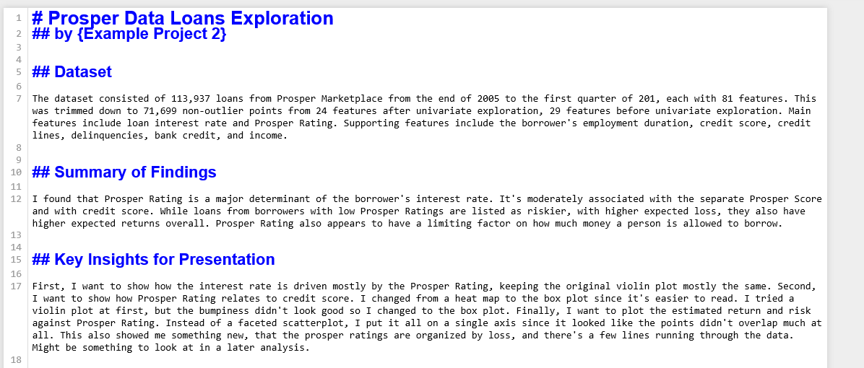](https://udacity-reviews-uploads.s3.us-west-2.amazonaws.com/_attachments/514237/1611997488/readme_2.png)

**A slideshow is provided, with at least three visualizations used in the presentation to convey key insights. These key insights match those documented in the summary. Each visualization is associated with comments that accurately depict their purpose.**

Dear student great job generating the slideshow but as suggested by the previous reviewer there are few changes that are to be made to make your slideshow perfect.

**I am listing down the changes that are to be made please go through it.**

1. The slideshow should not contain any type of code. please remove it.

[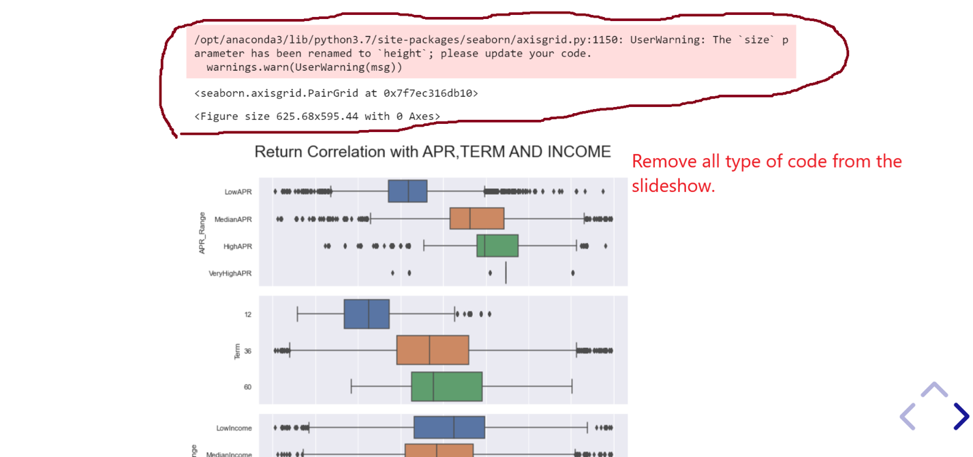](https://udacity-reviews-uploads.s3.us-west-2.amazonaws.com/_attachments/514237/1611998344/tempsnip.png)

[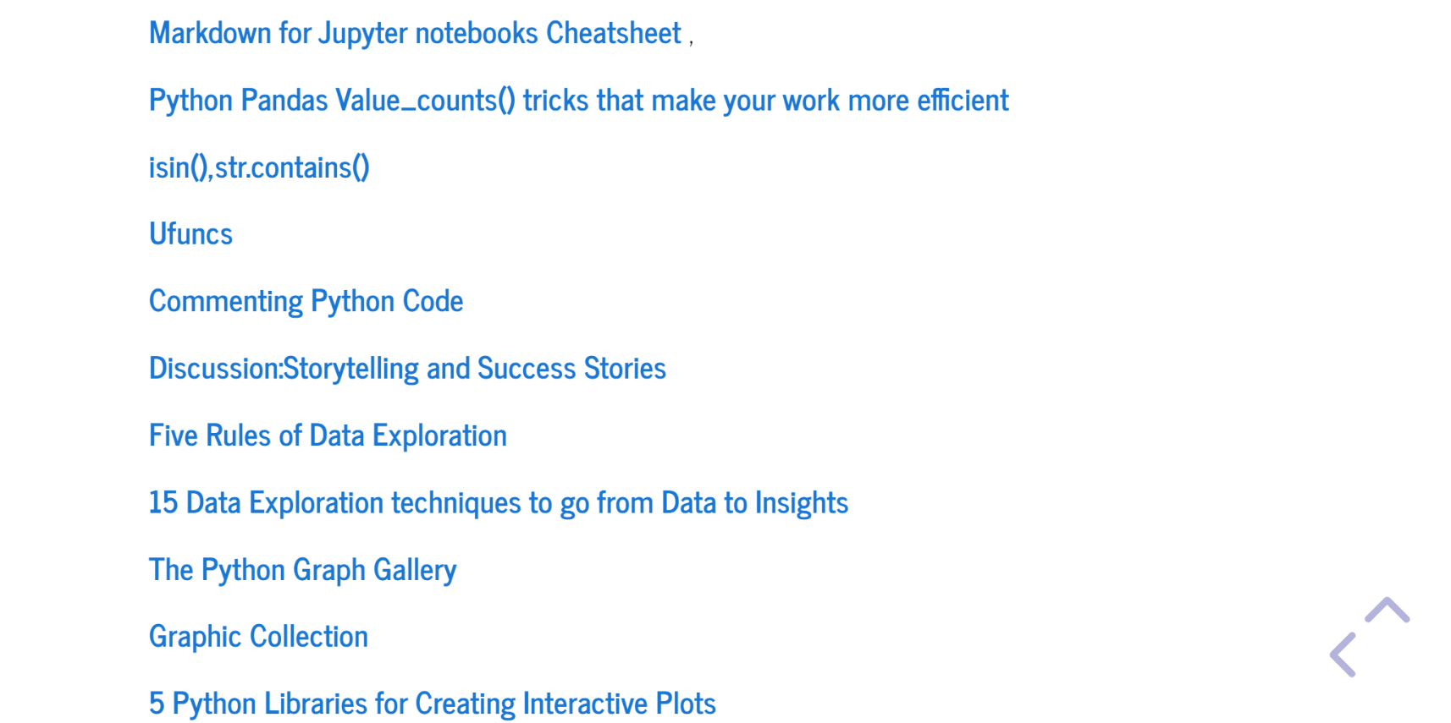](https://udacity-reviews-uploads.s3.us-west-2.amazonaws.com/_attachments/514237/1611998431/Capture.PNG)

**Note:-**

**Include only 5 or 6 most important plots in your slideshow.**

**For reference**

[](https://udacity-reviews-uploads.s3.us-west-2.amazonaws.com/_attachments/514237/1611998708/slideshow.gif)

**All plots in the presentation have an appropriate title with labeled axes and legends. Labels include units as needed. Plot type, encodings, and transformations are all appropriate.**

This rubric will be evaluated once the above rubrics are evaluated.

**Points to be kept in mind while generating the slideshow :**

* Plots should be appropriately sized and preferably constant across the plots.  
  For an A4 (portrait) page size use : plt.figure(figsize=[ 11.69, 8.27])
* Plots are completely polished. A Title, readable axis labels (both) (with units), and a legend (if required) should be given to each plot. Here readable means to use meaningful phrases rather than column-names from the dataset directly!
* Detailed observation is present for each visualization.
* No code elements or chart junk should be present in the plots.
* There should be no overflowing of content - neither plot nor text!